“SECRET TO SUCCESS-DETERMINATION, DEDICATION AND DISCIPLINE”.
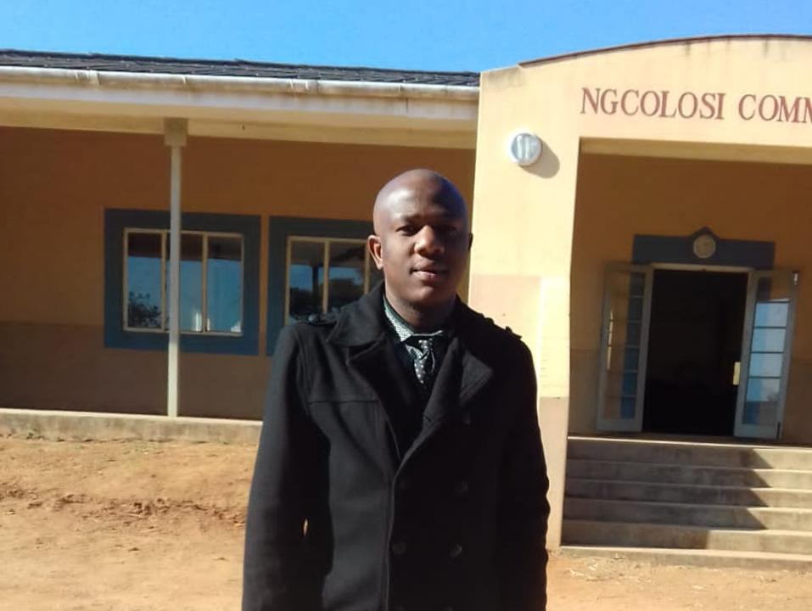
Photo: HABandBF Bachelor of Education graduate Bonga Bhengu
Cebisile Ngobese
Bachelor of Education graduate Bonga Comfort Bhengu said in order to be successful in life, one has to be a kind of person who is dedicated, determined and disciplined, amongst other qualities.
38 year old Bhengu lives in KwaNgcolosi a rural area near Hillcrest, Durban-South Africa. Both his parents passed away when he was between the ages of 20 and 25. He is a sole breadwinner in his family and is survived by three siblings, one of which is disabled.
He studied his lower level education at Ndlokolo Primary School, studied his higher level education at Hlahlindlela High School and proceeded to KwaBazothini High School, which is where he matriculated. Because of difficult circumstances that he and his family were faced with at that time, he was unable to enroll for tertiary straight after matriculating, so instead, he decided to seek for employment because he needed to cater for himself and his siblings.
He then found a job in the year 2004 where he served under a fixed contract which later got terminated in the year 2008. He stated that after his contract got terminated, ‘he thought it best to go back to school so that to enable him to find better and permanent employment in future’.
“In 2009 I went back to school to upgrade my matric results. After I achieved that, I started to apply to various tertiary institutions and then I got accepted by the University of South Africa (UNISA) which is where I graduated with a Bachelor of Education-Senior and FET Phase, with a booming 19 distinctions”, he said.
He said he is very grateful for all the support and assistance he received from the non-profit organisation called The Hillcrest Advice Bureau and Bursary Fund. He reported that they supported him financially, provided him with study material, transport, life skills etc.
“I would like to thank the Hillcrest Advice Bureau and Bursary Fund Organisation for supporting me throughout my studies. I would like to extend further my gratitude to Chairperson of HABandBF Mrs Tanya Harvey and the entire team and also various stakeholders who contribute donations to ensure that we receive education”, said Bhengu.
He now works as a qualified teacher at Labourer Primary School and is also currently studying for Bachelor of Accounting Sciences in Financial Accounting (BCOM) at UNISA.
Either than being very good student, Bhengu is also a very humble person who aims high and wishes to achieve only the best. He said, “I wish to further my studies ultimately. Achieve a doctorate degree in education, BeCOM in Accounting, Honours in curriculum studies, Masters in curriculum studies and Doctorate in curriculum studies. I also wish to be able to give back to underprivileged societies.”
“The secret to success is a combination of many things, such as determination, dedication, discipline, time management, respect, setting time frame, applying relevant methods in your studies and aiming high in your life. My advice to young people is that grasp every opportunity that God gives you. Work hard, be honest to yourself, do justice to yourself, disclose unwavering commitment and associate yourself with relevant people. These combinations will produce fantastic results in your life”, he continued.

